PROJECT ACTIVITY REPORT – FY 2025–26
Project Areas:
Education | Sports | Menstrual Hygiene | Women Empowerment | Scholarships | Healthcare & Community Support

Introduction
During the Financial Year 2025–26, Needuva Hrudhaya Foundation – Heart of Giving continued its dedicated journey towards building inclusive and empowered communities across Karnataka. Through carefully designed interventions in education, menstrual hygiene, women empowerment, healthcare, sports, and community welfare, the Foundation has addressed critical grassroots challenges with sustainable solutions.
Our approach goes beyond support—it focuses on dignity, access, and long-term transformation, ensuring that every individual, especially girls and women, can lead a life of confidence and opportunity.

Financial Overview
Total Funds Utilized: ₹21,22,700.97
Project Category | Amount (₹) | % Allocation
Pink Room (Menstrual Hygiene) | 6,88,924.83 | 32.40%
Computer Lab (Digital Education) | 8,61,049.69 | 40.60%
Other Key Projects | 5,15,286.14 | 24.30%
Administrative Expenses | 57,440.31 | 2.70%

2. Project Activities with Locations & Impact

2.1 Pink Room – Menstrual Hygiene Initiative
Locations:
- Government High School, MM Hills – Mysore District
- SSEA College, Gowribidanur – Chikkaballapur District
- Government High School, Devanahalli – Bangalore Rural District

The Pink Room Concept, a flagship initiative of the Foundation, addresses menstrual hygiene challenges faced by adolescent girls in schools and colleges.

Impact:
- Benefiting 5,000+ girl students annually
- 10–12% increase in attendance among girls
- Reduction in absenteeism during menstruation
- Improved confidence, awareness, and dignity
Key Facilities:
- Private and safe hygiene rooms
- Sanitary pad vending machines
- Eco-friendly incinerators
- Resting areas and study spaces
- Continuous awareness sessions

Meaningful Reflection:
Periods are natural. Stigma is not.
Menstrual hygiene is not a privilege—it is a fundamental right linked to education, health, and equality.

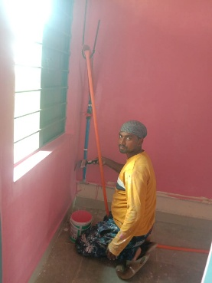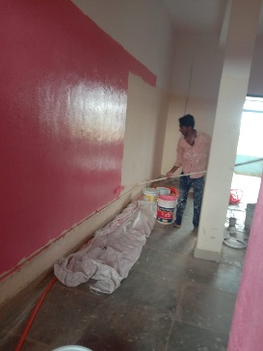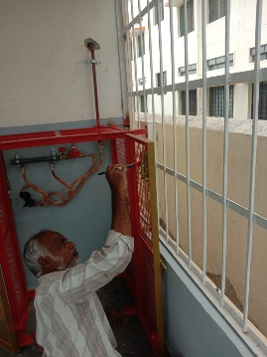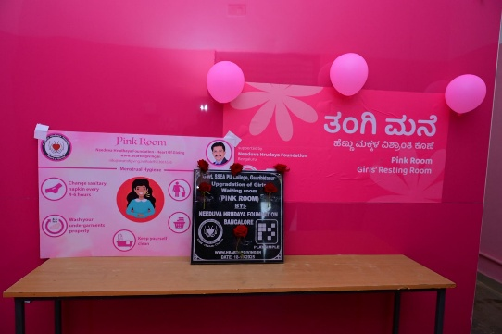
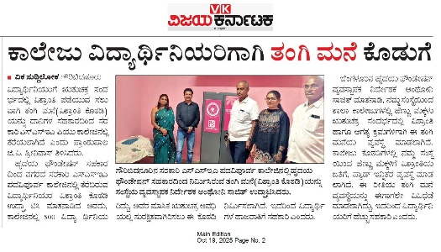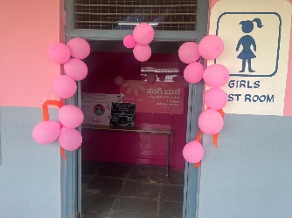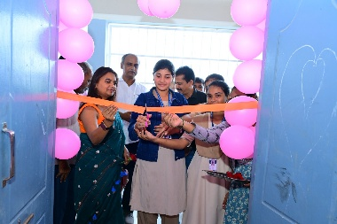
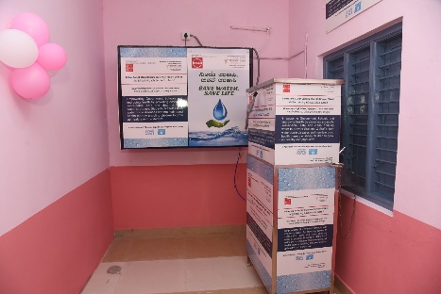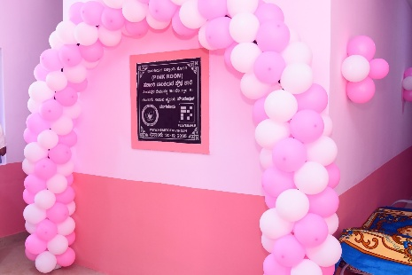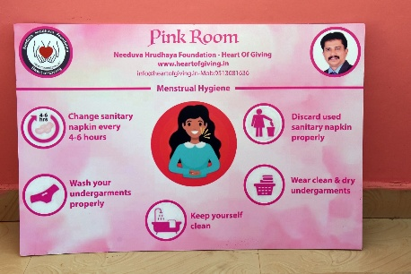
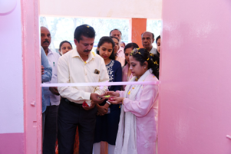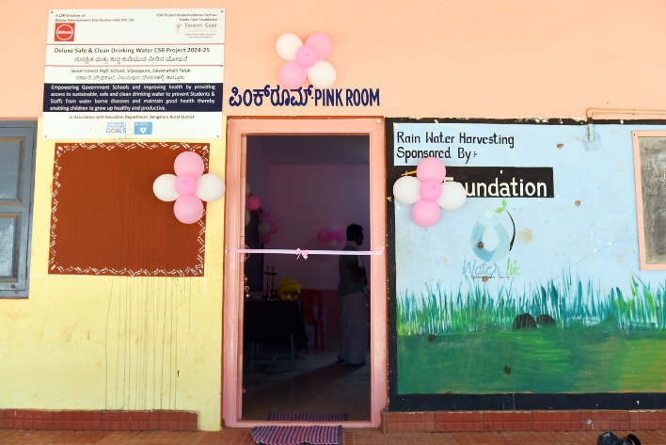
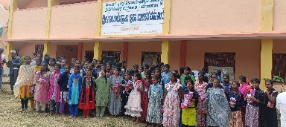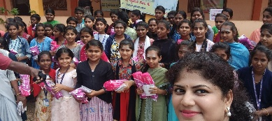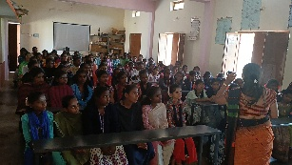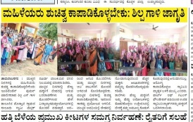
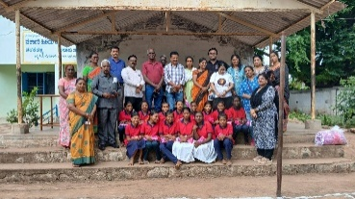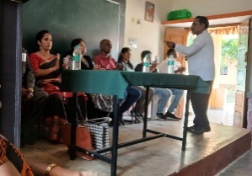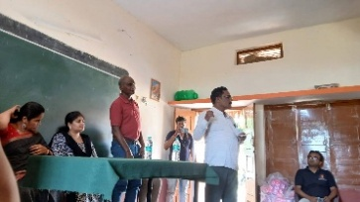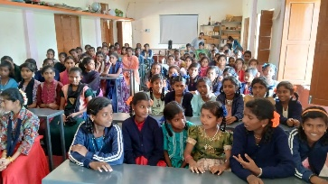

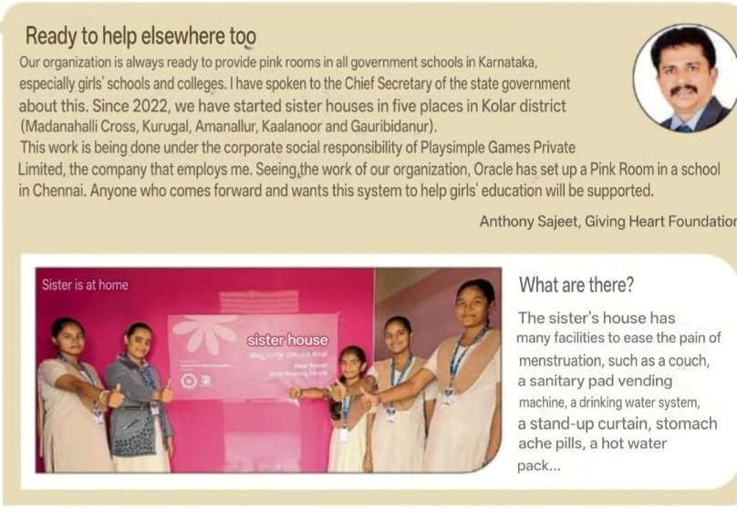
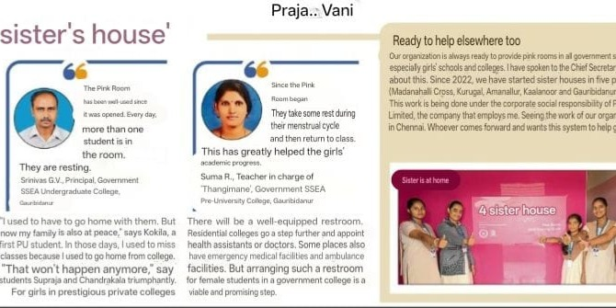
2.2 Computer Lab – Digital Empowerment Initiative
Locations:
- Govt. High School, Belmaranahalli – Kolar District
- Moulana Azad Model & PU College – Kolar District
- Govt. High School, Bellahalli – Kolar District
- Nehru Kennedy PU College, Mulbagal – Kolar District
- Govt. PU College, Rajakallahalli – Kolar District
- Government Library – Kolar District
- District Armed Reserve (DAR), Mulbagal – Kolar District Police
This initiative focuses on bridging the digital divide in rural education systems.

Impact:
- Strengthened digital learning infrastructure
- Access to computer education for rural students
- Enhanced academic exposure and skill development
- Benefiting 10,000+ students annually

Outcome:
- Functional computer labs with modern systems
- Improved digital literacy
- Increased student motivation and engagement
- Support to public institutions for improved service delivery

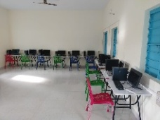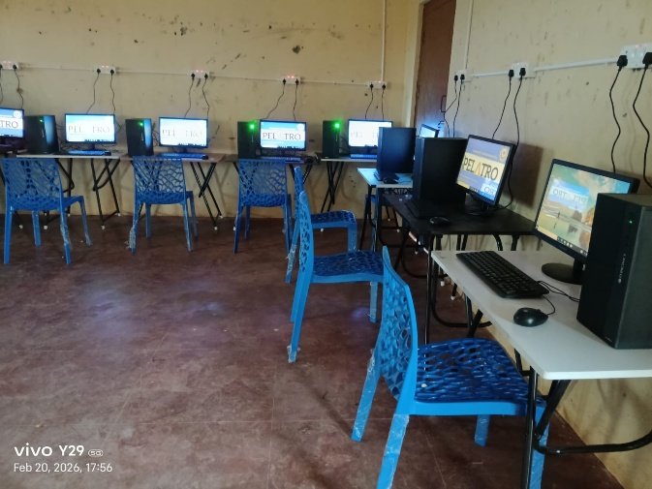
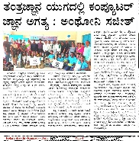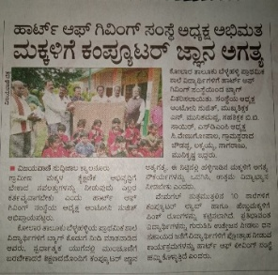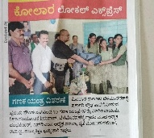
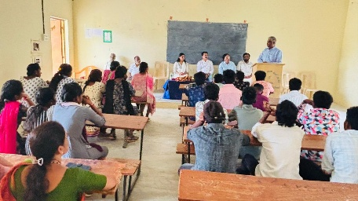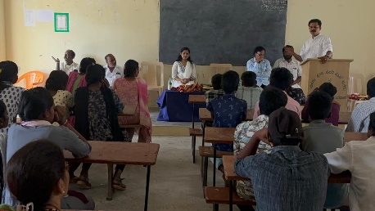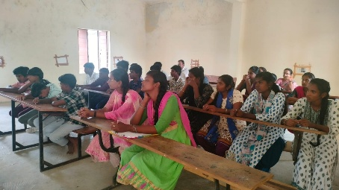
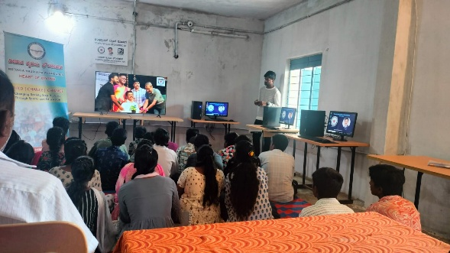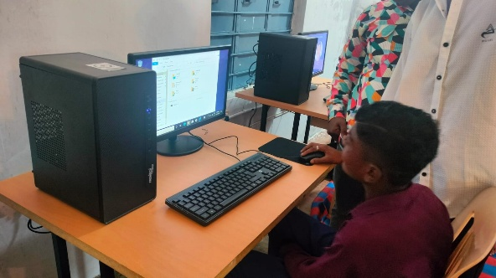
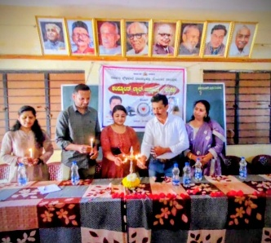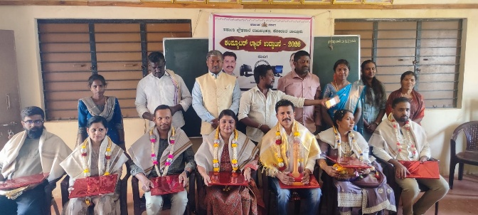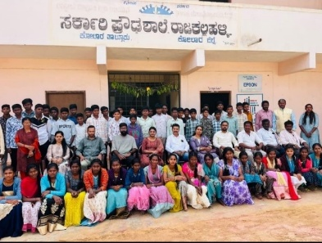
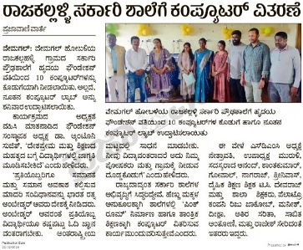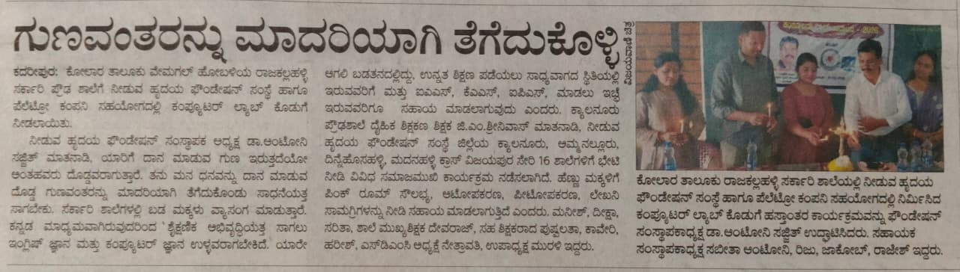
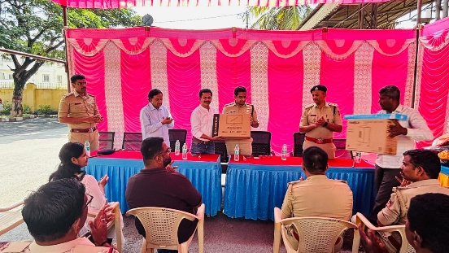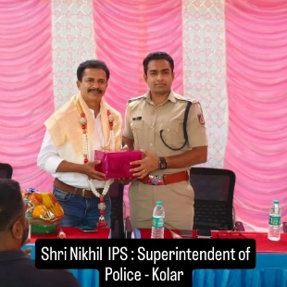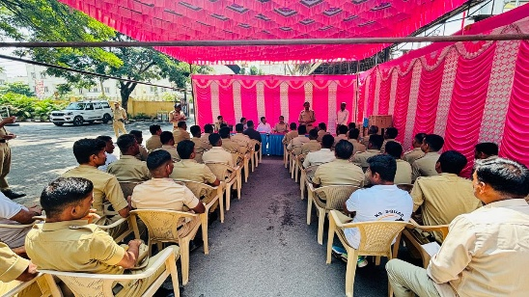
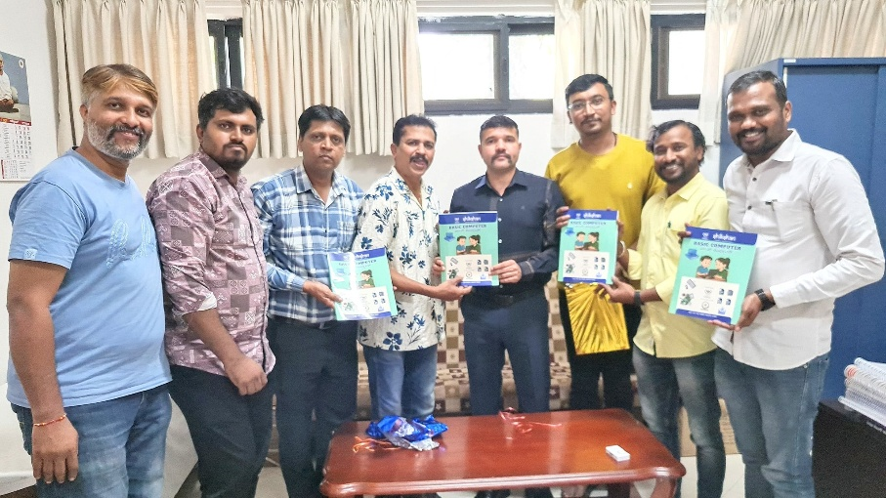
2.3 Education Support – Scholarships & Learning Resources
Locations: Bengaluru, Kolar District and surrounding regions

The Foundation supported students from diverse academic backgrounds to ensure uninterrupted education.

Support Includes:
- Tuition fee sponsorships
- Laptop and desktop distribution
- Cash awards for academic excellence
- Support to PU, engineering, and professional course students
These initiatives helped students overcome financial barriers and pursue higher education with confidence.

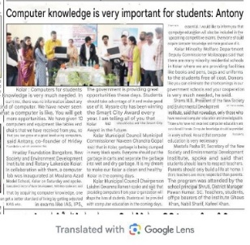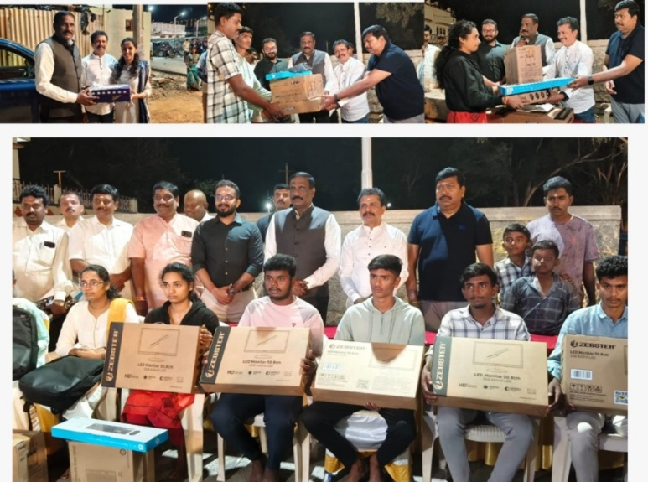
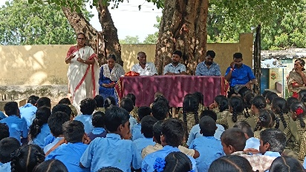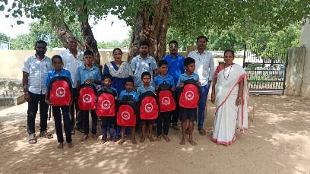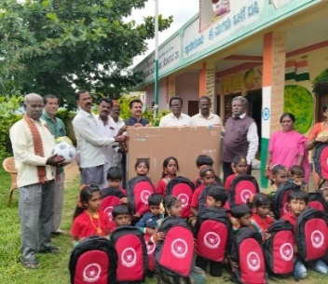

2.4 Sports Promotion – School-Level Development
Locations:
- Morarji Desai Residential School (SC-47), Devaraya Samudra, Mulbagal Taluk – Kolar District
The Foundation actively promoted sports to encourage physical well-being and teamwork among students.
Support Provided:
- Sports kits (football, cricket, volleyball, shuttle, etc.)
- Study materials and school essentials
- Track suits for U-17 Boys’ Kabaddi Team
Achievement:
- Secured 1st place at District Level Kabaddi Tournament
- Qualified for Bangalore Divisional Level Tournament
This initiative nurtures discipline, leadership, and confidence among young students.

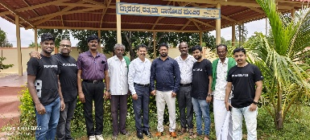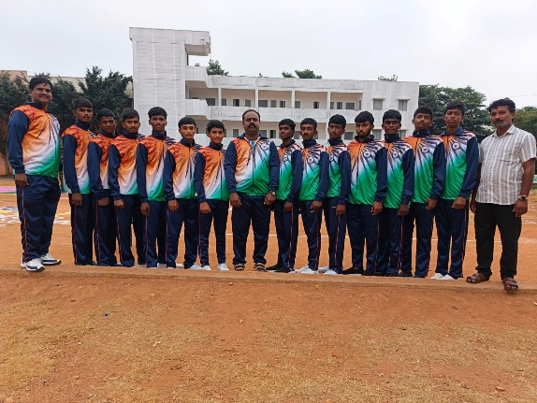

2.5 Women Empowerment – Tailoring Skills Initiative
Location:
- Somnathapura Village, Bagepalli Taluk
This initiative empowers rural women through vocational skill development.

Impact:
- Women trained in tailoring through structured batches
- Successful establishment of home-based businesses
- Increased and sustainable income generation
Post training, sewing machines were provided to enable entrepreneurship.

Inspiration:
A meal can satisfy momentarily, but a skill creates lifelong independence.

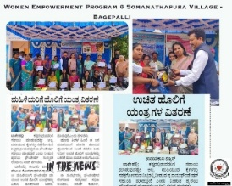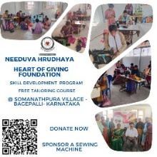
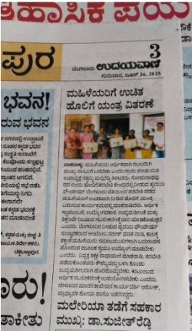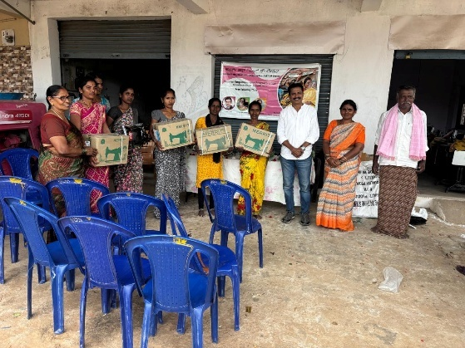

2.6 Healthcare – Medical Treatment Support
The Foundation extended financial assistance for medical treatments to individuals in need, ensuring timely healthcare access for underserved communities.
Impact:
- Support for critical medical cases
- Reduced financial burden on families
- Improved access to healthcare services

2.7 Community Welfare Initiatives
Locations: Bengaluru & Kolar District
- Recognition and appreciation of BBMP workers for their essential services
- Strengthening public institutions through digital support
- Donation of computer systems to District Armed Reserve (DAR), Kolar
These efforts highlight the Foundation’s commitment to community well-being and institutional strengthening.

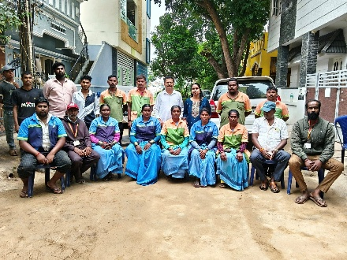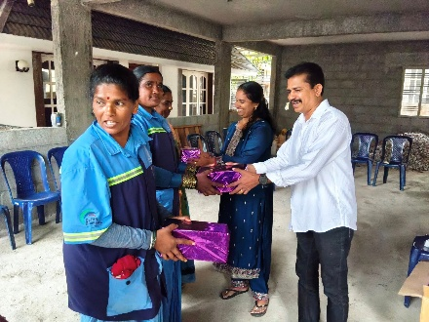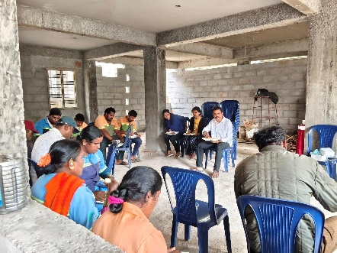
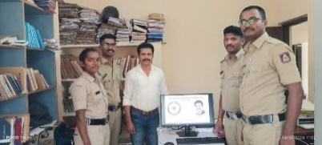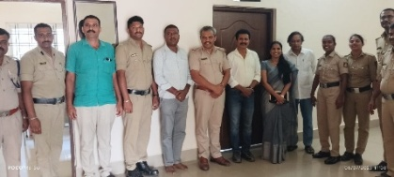

3. Awards & Recognition – Pink Room Initiative
The Pink Room initiative has received prestigious recognition:
- Featured on the cover of Business Talkz – The Indian Achievers (2026)
- National Award for Excellence 2025 – Best CSR Initiative
- Karnataka Idol Award 2025
- Abhaya Bravery Award 2024
- Shikshan Award 2024
This pioneering initiative was strongly supported by PlaySimple Games Pvt. Ltd., the first CSR partner in India to fund the Pink Room concept, setting a benchmark in social innovation.
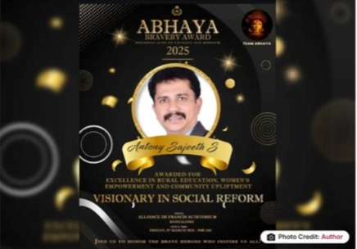

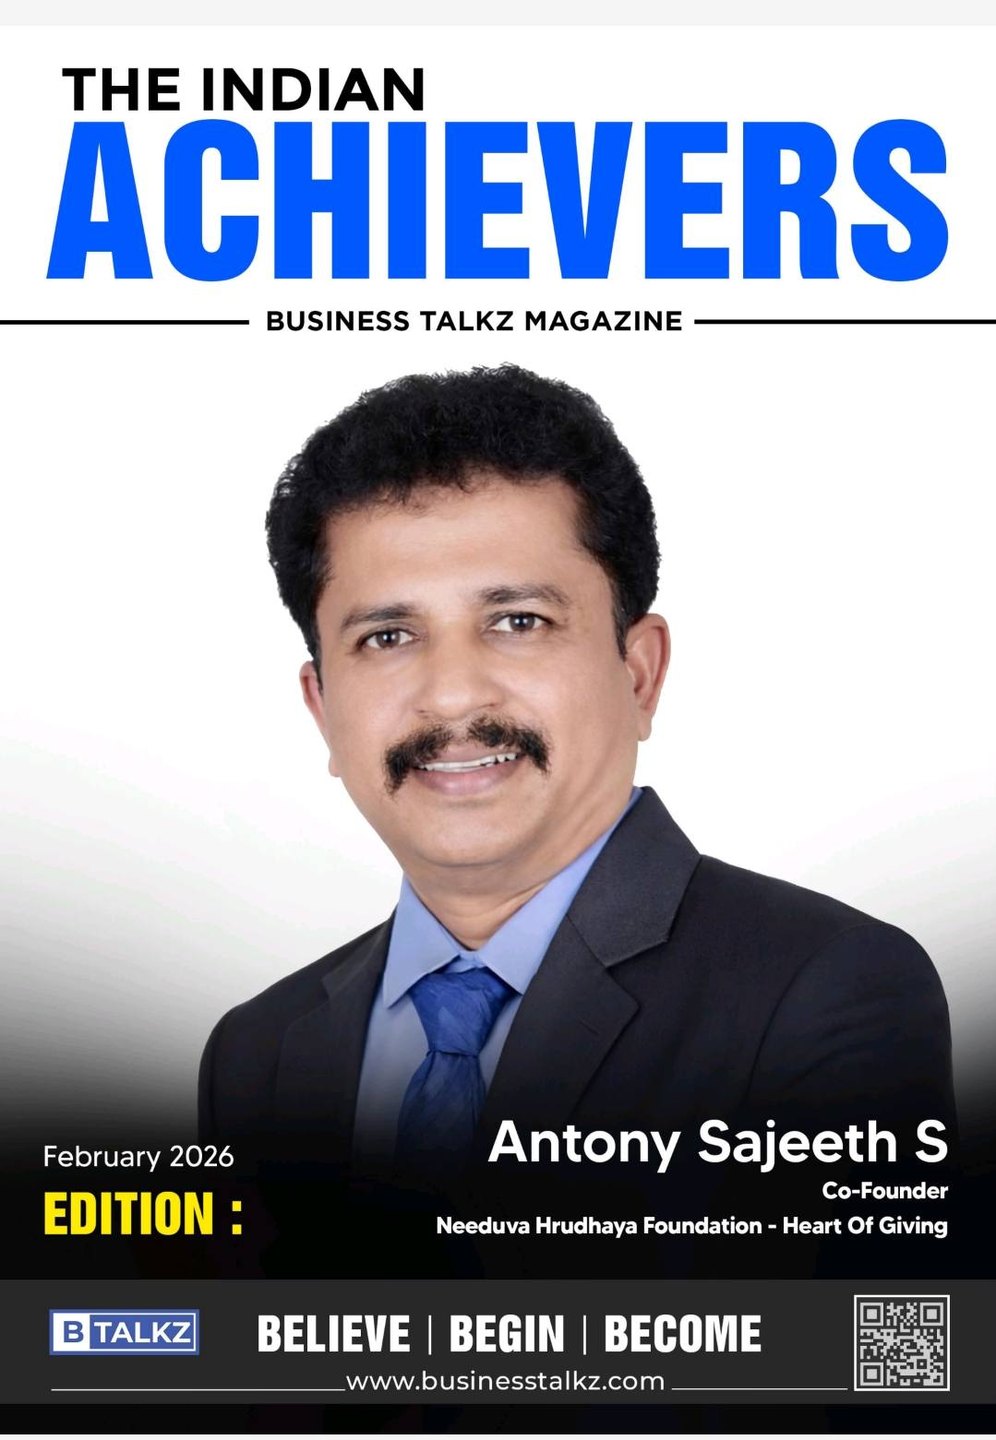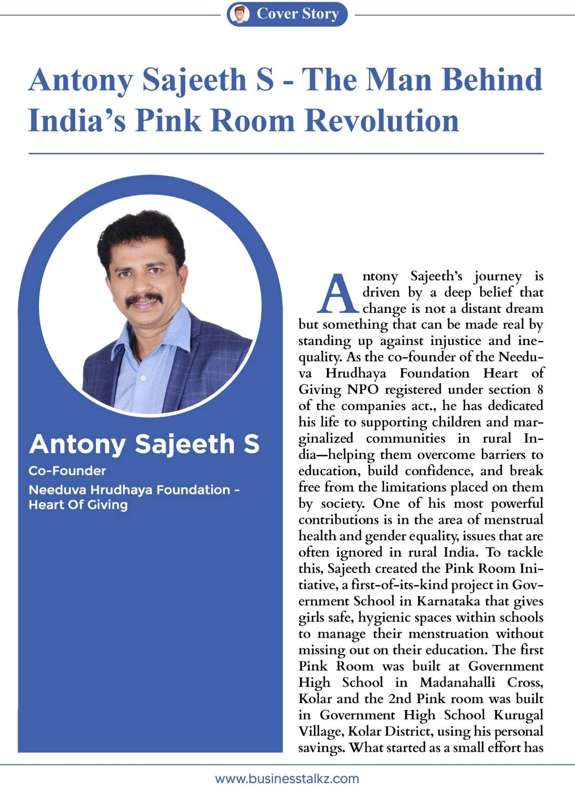

4. Conclusion
The Financial Year 2025–26 stands as a testament to the transformative impact of Needuva Hrudhaya Foundation – Heart of Giving. Each initiative—whether enabling a girl to attend school with dignity, equipping a student with digital skills, or empowering a woman to become self-reliant—reflects a deep commitment to meaningful change.
Our Vision:
To build a society where dignity, education, health, and opportunity are accessible to every individual, especially the underserved.

Thanks & Regards
Antony Sajeeth S
Founder - Director
Needuva Hrudhaya Foundation - Heart of Giving
Mobile : 9513081636
www: heartofgiving.in
youtube : @antonysajeeth4828

